Project Proposal: Cloud-Based Diagnostic Support System for Breast Cancer Detection

Problem Identification

Context
In many underserved regions, access to specialized oncologists is limited. Clinics often have basic equipment like microscopes, but lack experts to accurately assess breast cancer risk.

Gap
Routine staff—such as nurses—can collect cell samples and measurements, but cannot confidently diagnose malignancy, resulting in missed or delayed treatment.

Solution
A cloud-based diagnostic system - “Smart Oncological Triage System” - enables any trained health worker to input cell measurements into a web app, which uses machine learning to instantly assess cancer risk.

How it Works
Data from a sample is entered into the app and processed by an AWS-hosted predictive model, delivering an immediate diagnosis and confidence score.

Impact
Empowers rural clinics to perform early triage, prioritize urgent cases for referral, and optimize scarce healthcare resources—leading to faster, life-saving interventions.

Leveraged Data
The Dataset: We will utilize the Wisconsin Diagnostic Breast Cancer (WDBC) dataset Data Points: 569 instances.
https://archive.ics.uci.edu/dataset/17/breast+cancer+wisconsin+diagnostic
- Features: 30 real-valued vector features (Radius, Texture, Perimeter, Area, Smoothness, etc.).
- Target: Diagnosis (M = Malignant, B = Benign).

System Architecture & Features

End-to-End Data Journey
- Medical Personnel collect patient samples and analyze using digital microscopes + image analysis software.
- S3 Web Interface: User uploads the full 30-feature dataset generated by analysis software (no more manual subsetting).
- AWS API Gateway: Validates incoming data before triggering backend logic.

Prediction & Data Traceability
- AWS Lambda (Predictor):
  - Loads the latest trained model from S3 at runtime.
  - Consumes the validated 30-feature input, outputs malignancy prediction & confidence.
- Amazon DynamoDB:
  - Stores each prediction event: all features, prediction result, timestamp, and identifiers for future auditing or retraining.

Automated Notification & Feedback
- If “Malignant” prediction is returned:
  - Amazon SNS sends a notification.
  - Email alert triggers to inform the responsible doctor (allows for immediate follow-up or referral).
- Clinician receives prediction result and notification for high-risk cases.

Real-world Validation Integration
- Final validation: When extra clinical/laboratory diagnostics confirm or refute malignancy, these results are pushed into DynamoDB, and they are used to retrain the model.

Model Improvement: Scheduled Retraining Loop
- EventBridge Scheduler:
  - Triggers AWS Lambda (Retraining) weekly (every Sunday, 12AM).
  - Lambda pulls all records (with confirmed diagnoses) from DynamoDB.
  - Retrains SVM model on the expanded/validated dataset.
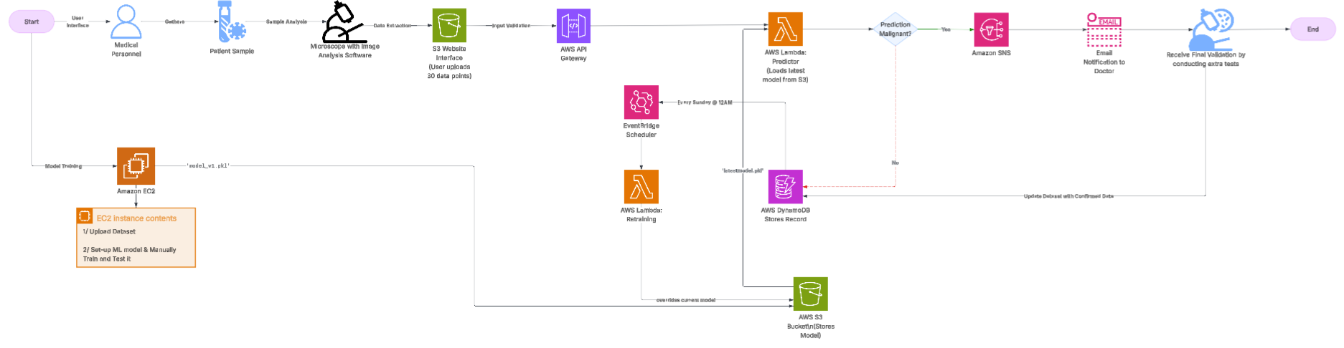
  - Saves the new .pkl model to S3, meaning all future predictions use the improved algorithm.
  - Ensures a true “learning healthcare system.”

AWS Architecture Diagram:

Complete Visual: https://lucid.app/lucidchart/18176970-7f1f-460c-b91d-8c09b7766270/edit?viewport_loc=-2427%2C-6305%2C6555%2C2978%2C0_0&invitationId=inv_bc3c4fd9-9fc1-41cf-bf56-e69908f439bc

Development Guidelines & Technical Setup

ML Pipeline—EC2 Bootstrapping:
- Data cleaning & EDA.
- Data scaling.
- Train SVM classifier & save scaler/model as .pkl.
- Initial model upload to S3.

Serverless AWS Setup (Free Tier):
- S3 Static Website for inputs.
- API Gateway for secure event-based Lambda invocation.
- AWS Lambda for inference and retraining.
- DynamoDB for full auditability and ongoing dataset growth.
- SNS for automated clinical alerts.

System Inputs & Outputs

User Input (Web Interface):
- 30 features collected via digital microscopy and automated analysis.
- Data uploaded (JSON/CSV) with sample ID, timestamp, and relevant metadata.
Lambda Output (Returned to API Gateway/front-end):
(Sample)
{
"diagnosis": "Malignant",
"confidence": "98%"
}
- If “Malignant”: Email alert sent via SNS.

Results & Continuous Improvement

Performance Metrics:
- Based on reference repo, evaluation will focus on Recall/Sensitivity to minimize missed malignancies.
- Continuous Learning: Real biopsy results logged via web interface; retraining loop integrates true clinical feedback automatically.

Limitations:
- Manual confirmation of true diagnosis must be entered for retraining (Via Website).

Conclusion:
This architecture leverages AWS serverless infrastructure to automate real-time cancer risk prediction, proactive notifications, and periodic model self-improvement—bringing advanced diagnostic support to under-staffed clinics.

